The following programs are conducted by IT Club during the year 2024-25:
- Tech Foundation - A Workshop on OS Installation & BIOS Setup Essentials
Date : 27th January 2025, Monday
The IT Club of MTM College conducted a hands-on workshop titled "Tech Foundation: A Workshop on OS Installation & BIOS Setup Essentials" on January 27, 2025. Led by Mr. Subin V and Mr. Safeerudheen K V, the session provided students with practical skills in BIOS setup and OS installation through live demonstrations and interactive learning.
EVENT -PHOTOS
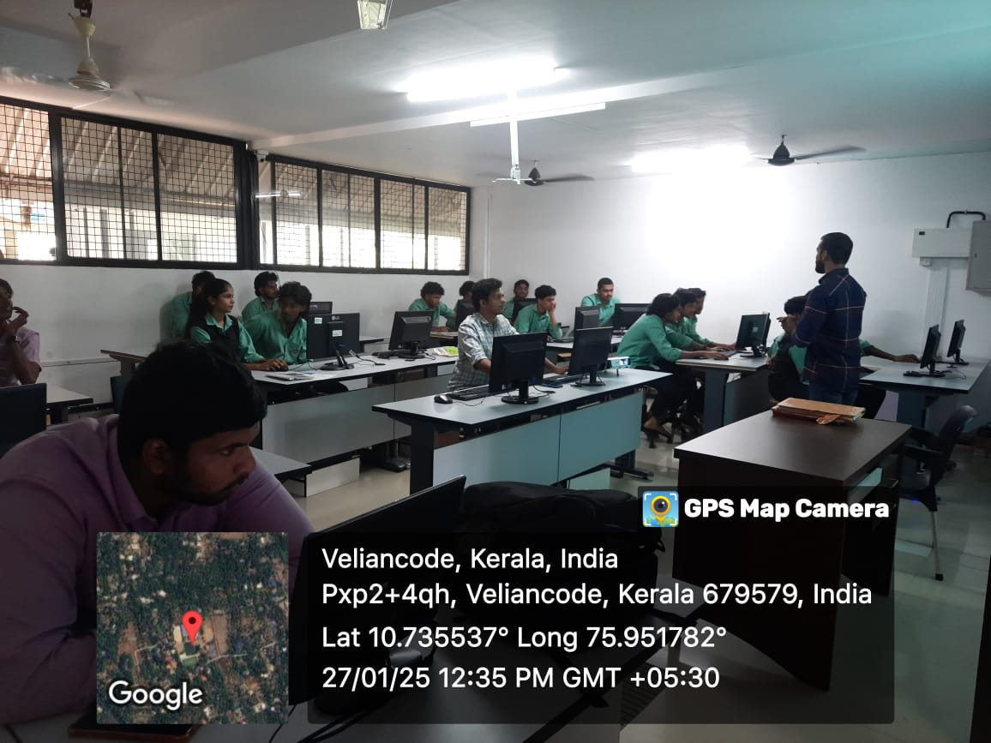 | 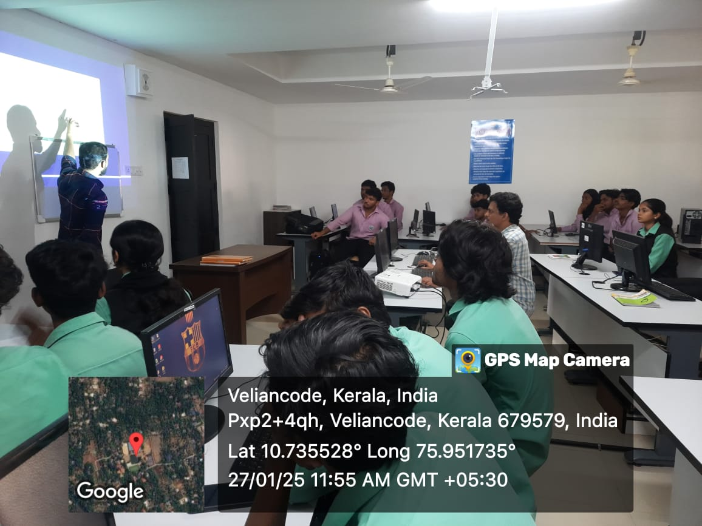
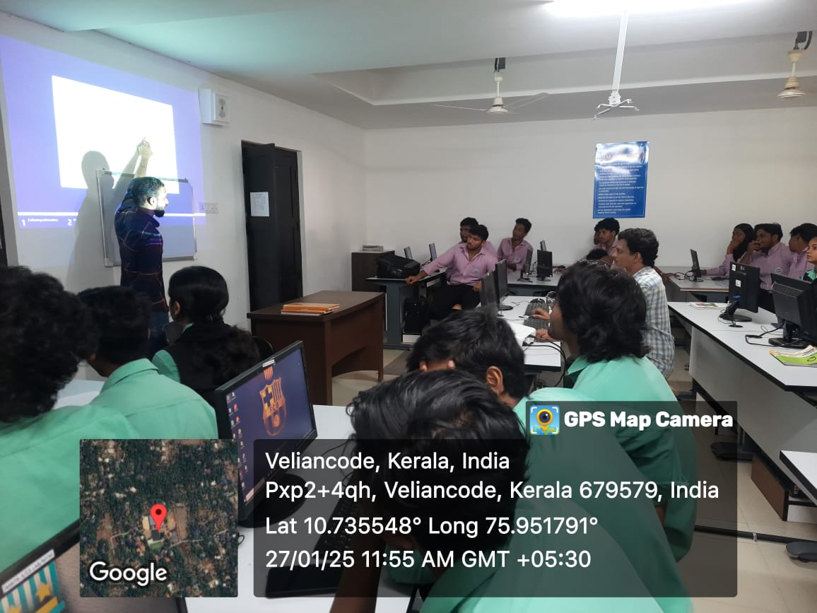 | 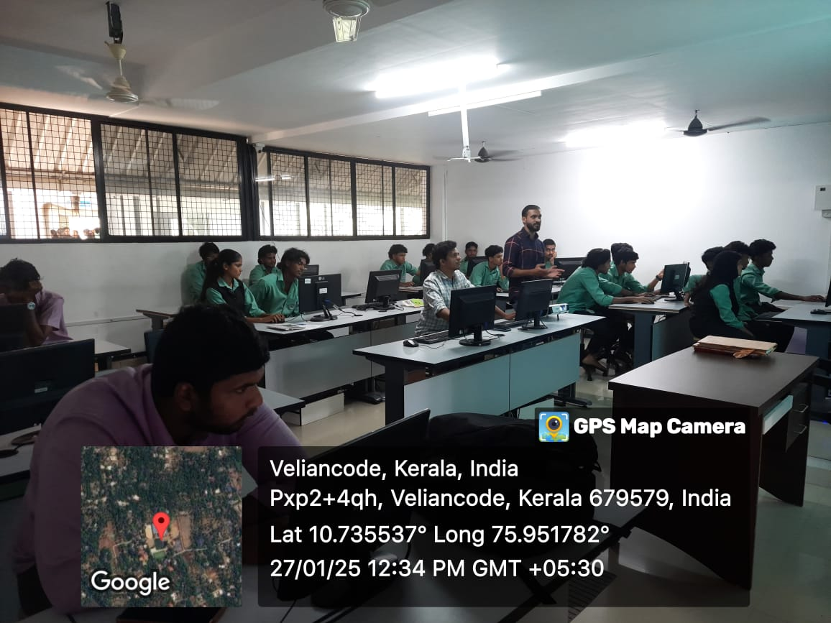
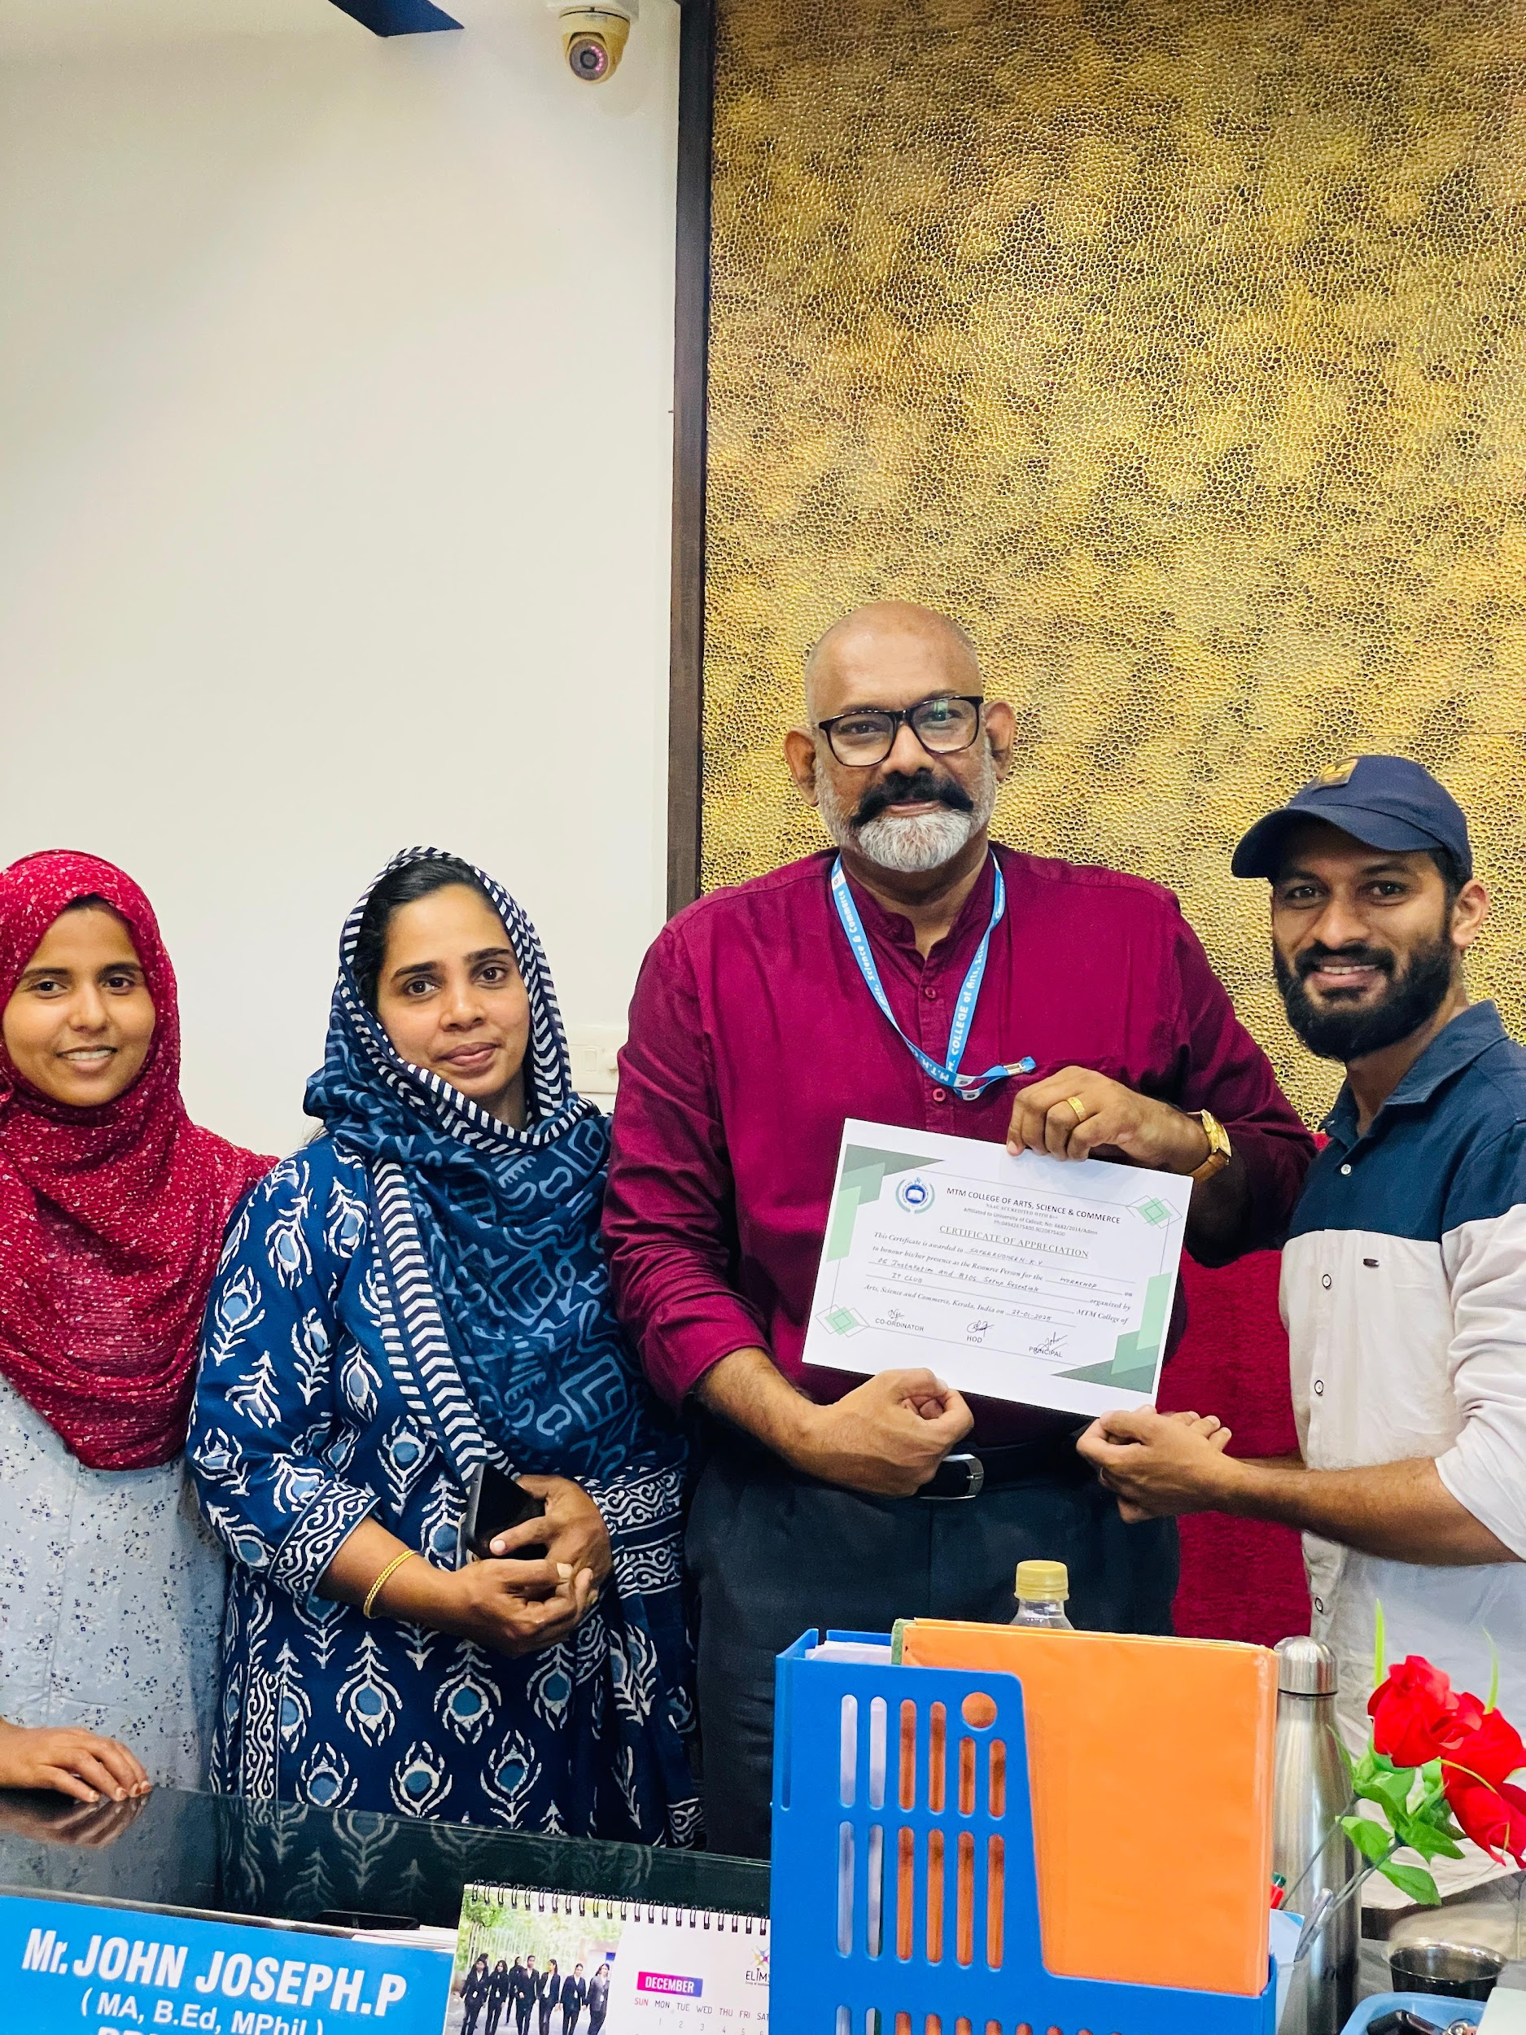 | 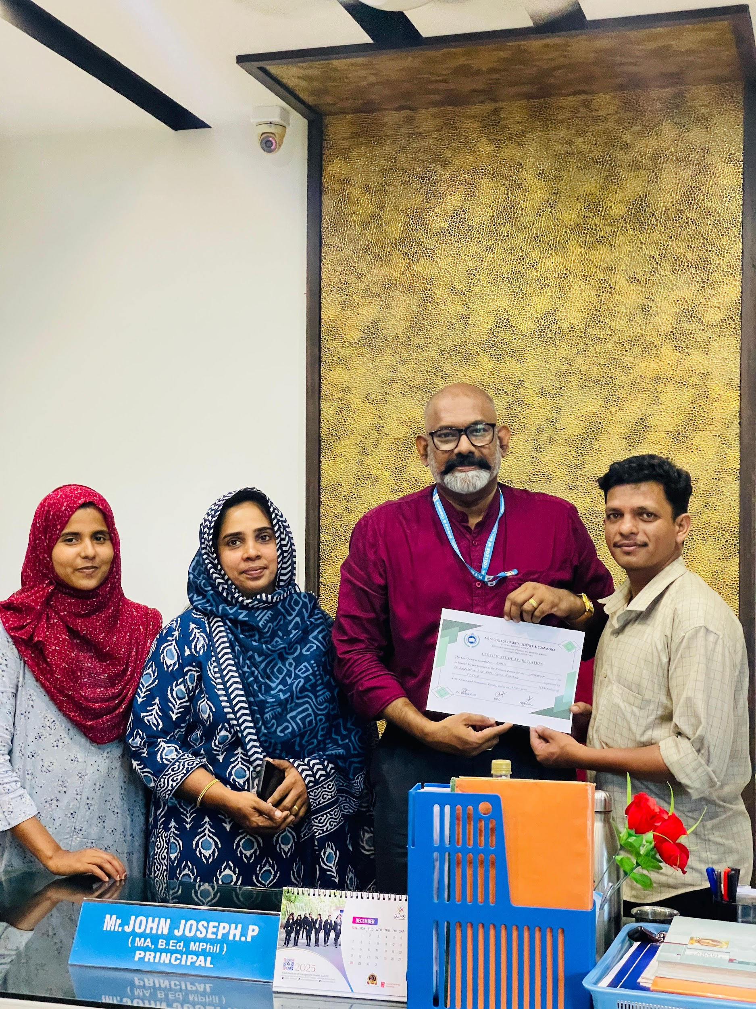

- PSC ONE TIME REGISTRATION DRIVE
Date : March 10 to 14, 2025
The IT Club of MTM College, in collaboration with IQAC, organized a PSC One-Time Registration Drive from March 10 to 14, 2025. Held in the college’s Computer Lab, the drive helped over 50 students complete their Kerala PSC registration with step-by-step guidance. Coordinated by Nafseera C, the initiative received positive feedback and aimed to enhance student readiness for government job applications.
EVENT -PHOTOS
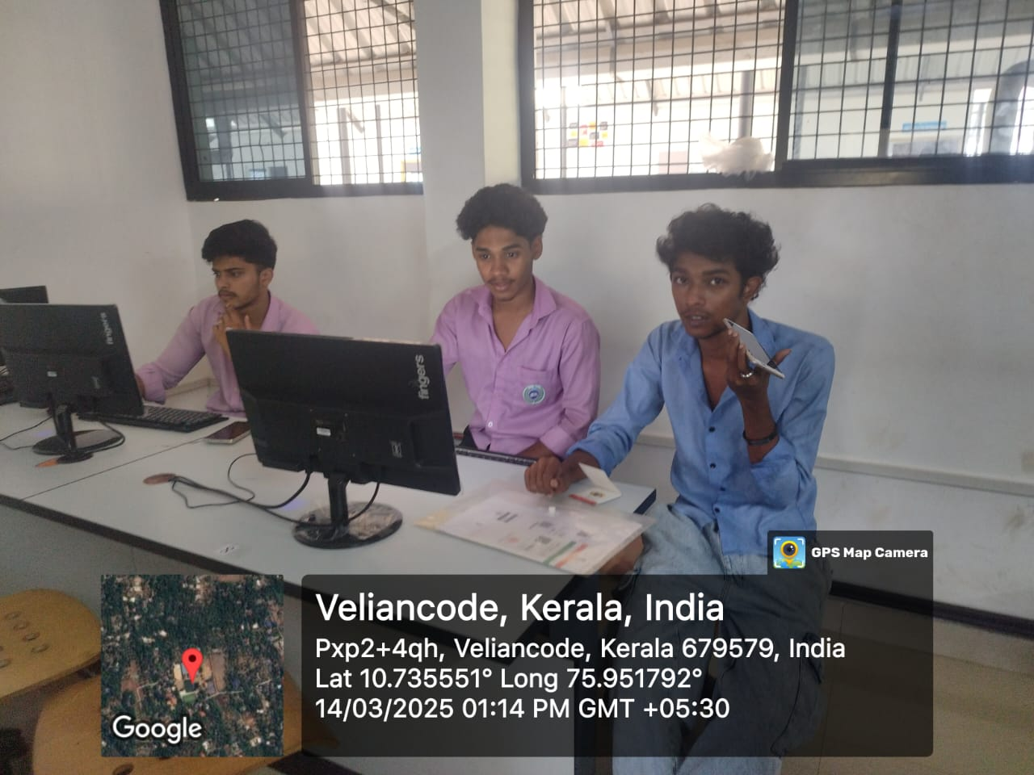 | 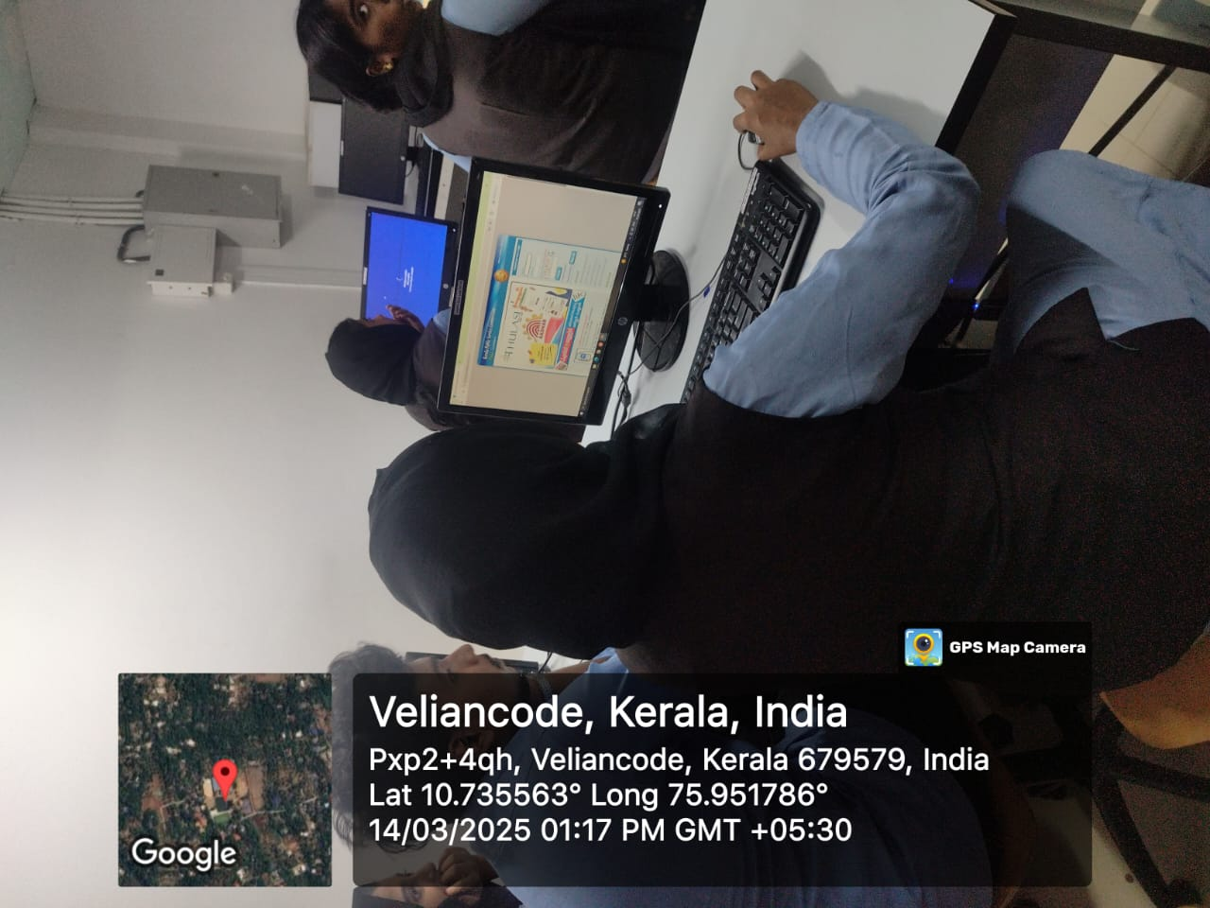
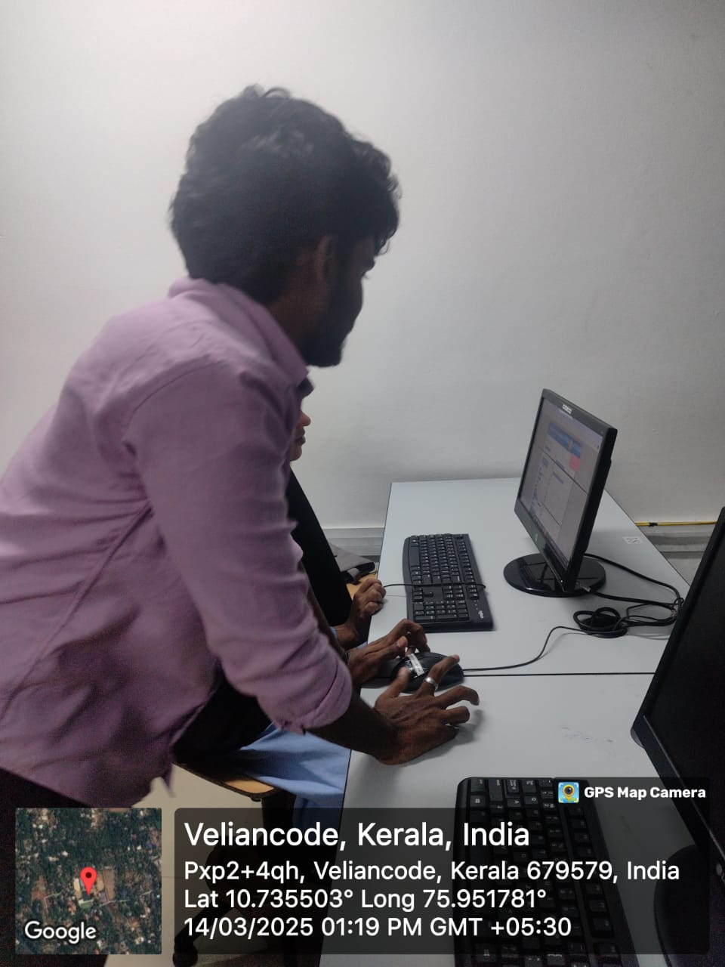 | 